Invoice Approval hierarchy Implementation.
Approval flow need to create as defined in sheet.
1st Approval should go to Vishal Singh “Commercial Executive”. Need to Create
2nd Approval should go to Ajay Kumar Tambi “Commercial Head”. Already Created
3rd Approval should go to Sirajuddin Ali “HOD”. Need to Create
4th Approval should go to Gokul Gupta “Finance”. Already Created

On Invoice details page Status Commercial Executive and Commercial head and HOD should be add.
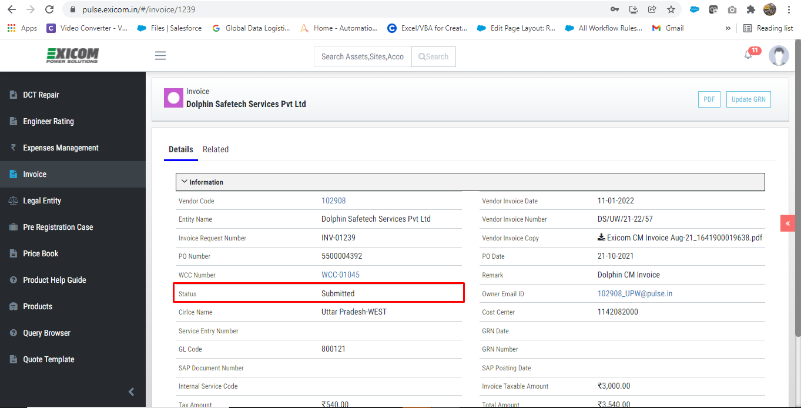
On Invoice details page Select Status Drop Down menu:
Approved By Commercial Executive
Approved By Commercial should be Approved by Commercial head
Approved By HOD
Rejected By Commercial Executive
Rejected By Commercial should be Rejected by Commercial head
Rejected By HOD



